## horizontal line



Car Fleet Management System

DBMS Project

**─**

Devanshi Dudhatra | 22BCP171

Heet Dobariya | 22BCP177

G5 | Division 3

# 

# Project Statement

* Project Overview: The project aims to develop a Car Fleet Management System that enables organizations to efficiently manage their vehicle fleet, including tracking vehicle usage, maintenance schedules, fuel consumption, and driver assignments.
* Use Cases (Applications):
  + Vehicle Management: Add, update, and retire vehicles from the fleet, track vehicle details such as make, model, year, VIN, and registration information.
  + Driver Management: Assign drivers to vehicles, track driver details such as name, license information, and contact details.
  + Maintenance Management: Schedule and track maintenance tasks for vehicles, record maintenance history, and generate alerts for upcoming services.
  + Trip Management: Track trips made by vehicles, including start and end locations, distance traveled, fuel consumption, and driver information.
* Objective: The objective is to create a comprehensive database management system that streamlines fleet operations, enhances vehicle utilization, and reduces maintenance costs.

# Entity Relationship Diagram

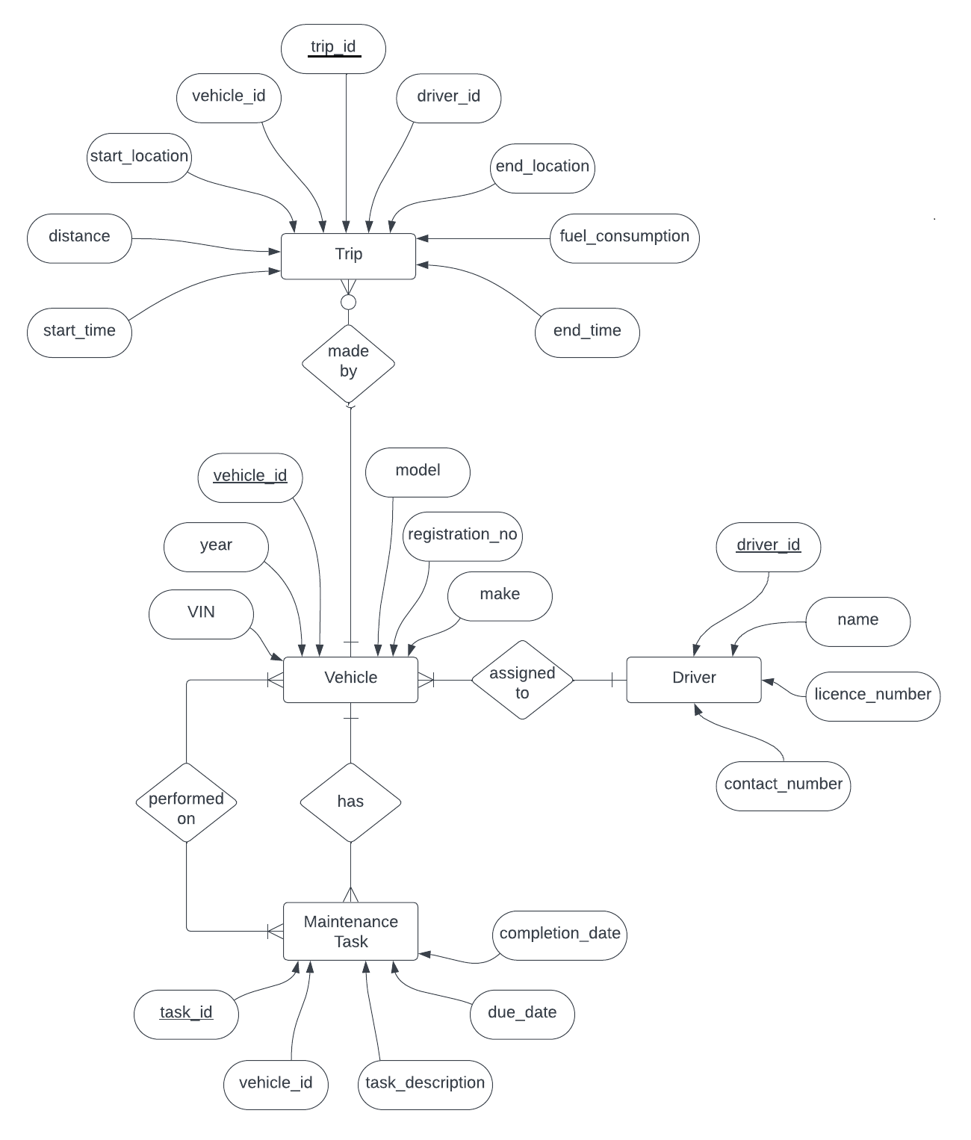

# Relational Model

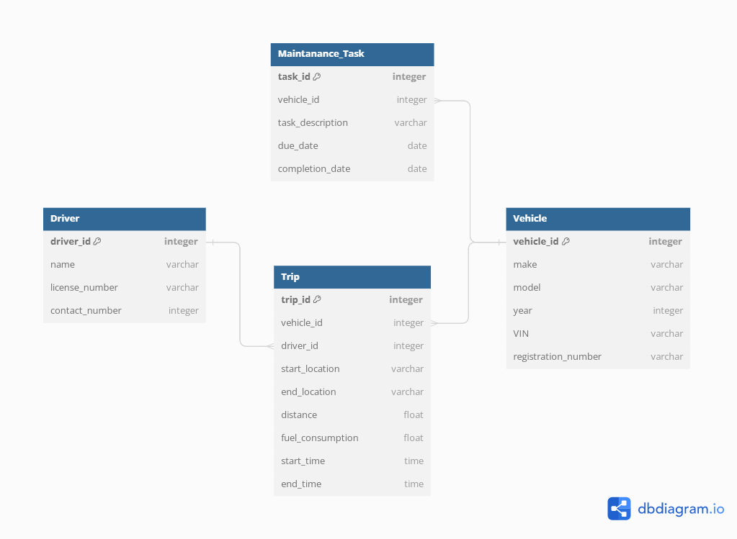

# Normalization

* **For Vehicle (vehicle_id, make, model, year, VIN, registration_number):**
  + Functional Dependencies -

vehicle_id → make, model, year, VIN, registration_number

VIN → vehicle_id

registration_number → vehicle_id

* Primary Key: vehicle_id (correctly identifies each vehicle)
* No partial dependencies on the primary key. Therefore, it is already in 2NF.
* Now as it is in 2NF and it does not have any transitive dependencies i.e. no non-key attribute is dependent on any other non-key attribute. Therefore, it is also in 3NF.
* Highest Normal Form: 3NF
* **For Driver (driver_id, name, license_number, contact_number):**
  + Functional Dependencies -

driver_id → name, license_number, contact_number

license_number → driver_id

* Primary Key: driver_id (correctly identifies each driver)
* No partial dependencies on the primary key. Therefore, it is already in 2NF.
* Now as it in 2NF and it does not have any transitive dependencies i.e. no non-key attribute is dependent on any other non-key attribute. Therefore , it is also in 3NF.
* Highest Normal Form : 3NF
* **For MaintenanceTask (task_id, vehicle_id, task_description, due_date, completion_date):**
  + Functional Dependencies -

task_id → vehicle_id, task_description, due_date, completion_date

vehicle_id → task_id

due_date → task_id

completion_date → task_id

* Primary Key: task_id (uniquely identifies each task)
* Foreign Key: vehicle_id references Vehicle(vehicle_id) (establishes link with a vehicle)
* No partial dependencies on the primary key or foreign key. Therefore it is in 2NF.
* It is also in 3NF.
* Highest Normal Form : 3NF
* **For Trip (trip_id, vehicle_id, driver_id, start_location, end_location, distance, fuel_consumption, start_time, end_time):**
  + Functional Dependencies -

trip_id → vehicle_id, driver_id, start_location, end_location, distance, fuel_consumption, start_time, end_time

vehicle_id → trip_id, driver_id, start_location, end_location, distance, fuel_consumption, start_time, end_time

driver_id → trip_id, vehicle_id, start_location, end_location, distance, fuel_consumption, start_time, end_time

start_location, end_location, start_time → trip_id

end_time → trip_id, start_time

* Primary Key: trip_id (uniquely identifies each trip)
* Foreign Key: vehicle_id references Vehicle(vehicle_id) (establishes link with a vehicle)
* Foreign Key: driver_id references Driver(driver_id) (establishes link with a driver)
* No partial dependencies on the primary key or foreign keys.
* Therefore it is in 2NF.
* Also there are no transitive dependencies. Therefore it is in 3NF also.
* Highest Normal Form : 3NF

# SQL Implementation

**a. Create tables with necessary integrity constraints using SQL DDL statements.**

CREATE TABLE Vehicle (

vehicle_id INT PRIMARY KEY,

make VARCHAR(50) NOT NULL,

model VARCHAR(50) NOT NULL,

year INT NOT NULL,

VIN VARCHAR(17) UNIQUE NOT NULL,

registration_number VARCHAR(20) UNIQUE NOT NULL

);

CREATE TABLE Driver (

driver_id INT PRIMARY KEY,

name VARCHAR(50) NOT NULL,

license_number VARCHAR(20) UNIQUE NOT NULL,

contact_number VARCHAR(20) NOT NULL

);

CREATE TABLE MaintenanceTask (

task_id INT PRIMARY KEY,

vehicle_id INT NOT NULL,

task_description VARCHAR(200) NOT NULL,

due_date DATE NOT NULL,

completion_date DATE,

FOREIGN KEY (vehicle_id) REFERENCES Vehicle(vehicle_id)

);

CREATE TABLE Trip (

trip_id INT PRIMARY KEY,

vehicle_id INT NOT NULL,

driver_id INT NOT NULL,

start_location VARCHAR(100) NOT NULL,

end_location VARCHAR(100) NOT NULL,

distance DECIMAL(10, 2) NOT NULL,

fuel_consumption DECIMAL(10, 2) NOT NULL,

start_time TIMESTAMP NOT NULL,

end_time TIMESTAMP NOT NULL,

FOREIGN KEY (vehicle_id) REFERENCES Vehicle(vehicle_id),

FOREIGN KEY (driver_id) REFERENCES Driver(driver_id)

);

**b. Populate tables with relevant data.**

INSERT INTO Vehicle VALUES (1, 'Toyota', 'Camry', 2022, '1HGCM82633A004352', 'ABC123');

INSERT INTO Vehicle VALUES (2, 'Honda', 'Civic', 2020, 'JHMEH61600S215688', 'XYZ456');

INSERT INTO Vehicle VALUES (3, 'Ford', 'F-150', 2019, '1FTEW1EP9KFA25866', 'DEF789');

INSERT INTO Vehicle VALUES (4, 'Chevrolet', 'Tahoe', 2021, '1GNSKBKC0KR105746', 'GHI987');

INSERT INTO Vehicle VALUES (5, 'Nissan', 'Altima', 2018, '1N4AL3AP9JC167719', 'JKL654');

INSERT INTO Driver VALUES (1, 'John Doe', '123456', '9876543210');

INSERT INTO Driver VALUES (2, 'Jane Smith', '654321', '1234567890');

INSERT INTO Driver VALUES (3, 'David Johnson', '789012', '2345678901');

INSERT INTO Driver VALUES (4, 'Emily Davis', '890123', '3456789012');

INSERT INTO Driver VALUES (5, 'Michael Brown', '901234', '4567890123');

INSERT INTO Driver VALUES (6, 'Mukesh', '901553', '4565455323');

INSERT INTO MaintenanceTask VALUES (1, 1, 'Oil Change', '2024-03-20', NULL);

INSERT INTO MaintenanceTask VALUES (2, 2, 'Tire Rotation', '2024-03-22', NULL);

INSERT INTO MaintenanceTask VALUES (3, 3, 'Brake Inspection', '2024-03-25', NULL);

INSERT INTO MaintenanceTask VALUES (4, 4, 'Oil Change', '2024-03-28', NULL);

INSERT INTO MaintenanceTask VALUES (5, 5, 'Fluid Check', '2024-03-30', NULL);

INSERT INTO Trip VALUES (1, 1, 1, 'City A', 'City B', 100.5, 10.2, '2024-03-14 09:00:00', '2024-03-14 12:00:00');

INSERT INTO Trip VALUES (2, 2, 2, 'City C', 'City D', 120.8, 9.8, '2024-03-15 10:00:00', '2024-03-15 13:00:00');

INSERT INTO Trip VALUES (3, 3, 3, 'City E', 'City F', 80.3, 12.5, '2024-03-16 11:00:00', '2024-03-16 14:00:00');

INSERT INTO Trip VALUES (4, 4, 4, 'City G', 'City H', 150.2, 11.2, '2024-03-17 12:00:00', '2024-03-17 15:00:00');

INSERT INTO Trip VALUES (5, 5, 5, 'City I', 'City J', 200.5, 10.0, '2024-03-18 13:00:00', '2024-03-18 16:00:00');

**c. Write various SQL queries for data retrieval related to the application.**

-- Retrieve all vehicles assigned to a specific driver.

SELECT * FROM Vehicle WHERE vehicle_id IN (SELECT vehicle_id FROM Trip WHERE driver_id = 1);

-- Retrieve maintenance tasks due for a specific vehicle.

SELECT * FROM MaintenanceTask WHERE vehicle_id = 1 AND due_date <= CURRENT_DATE;

-- Calculate total distance traveled by a specific vehicle.

SELECT SUM(distance) AS total_distance FROM Trip WHERE vehicle_id = 1;

-- Find average fuel consumption for all trips made by a specific vehicle.

SELECT AVG(fuel_consumption) AS average_fuel_consumption FROM Trip WHERE vehicle_id = 1;

# UI

import streamlit as st

import sqlite3

from PIL import Image

# Connect to SQLite database

def connect_to_db():

return sqlite3.connect("FleetManagement.db")

# Function to create tables

def create_tables():

conn = connect_to_db()

cursor = conn.cursor()

cursor.execute("""

CREATE TABLE IF NOT EXISTS Vehicle (

vehicle_id INTEGER PRIMARY KEY,

make TEXT NOT NULL,

model TEXT NOT NULL,

year INTEGER NOT NULL,

VIN TEXT UNIQUE NOT NULL,

registration_number TEXT UNIQUE NOT NULL

)

""")

cursor.execute("""

CREATE TABLE IF NOT EXISTS Driver (

driver_id INTEGER PRIMARY KEY,

name TEXT NOT NULL,

license_number TEXT UNIQUE NOT NULL,

contact_number TEXT NOT NULL

)

""")

cursor.execute("""

CREATE TABLE IF NOT EXISTS MaintenanceTask (

task_id INTEGER PRIMARY KEY,

vehicle_id INTEGER NOT NULL,

task_description TEXT NOT NULL,

due_date DATE NOT NULL,

completion_date DATE,

FOREIGN KEY (vehicle_id) REFERENCES Vehicle(vehicle_id)

)

""")

cursor.execute("""

CREATE TABLE IF NOT EXISTS Trip (

trip_id INTEGER PRIMARY KEY,

vehicle_id INTEGER NOT NULL,

driver_id INTEGER NOT NULL,

start_location TEXT NOT NULL,

end_location TEXT NOT NULL,

distance DECIMAL(10, 2) NOT NULL,

fuel_consumption DECIMAL(10, 2) NOT NULL,

start_time TIMESTAMP NOT NULL,

end_time TIMESTAMP NOT NULL,

FOREIGN KEY (vehicle_id) REFERENCES Vehicle(vehicle_id),

FOREIGN KEY (driver_id) REFERENCES Driver(driver_id)

)

""")

conn.commit()

conn.close()

# Function to insert data into a table

def insert_data(table_name, data):

conn = connect_to_db()

cursor = conn.cursor()

columns = ', '.join(data.keys())

placeholders = ', '.join(['?'] * len(data))

query = f"INSERT INTO {table_name} ({columns}) VALUES ({placeholders})"

cursor.execute(query, list(data.values()))

conn.commit()

conn.close()

# Function to delete data from a table

def delete_data(table_name, condition):

conn = connect_to_db()

cursor = conn.cursor()

query = f"DELETE FROM {table_name} WHERE {condition}"

cursor.execute(query)

conn.commit()

conn.close()

# Function to search data from a table

def search_data(table_name, search_criteria):

conn = connect_to_db()

cursor = conn.cursor()

query = f"SELECT * FROM {table_name} WHERE {search_criteria}"

cursor.execute(query)

data = cursor.fetchall()

conn.commit()

conn.close()

return data

# Streamlit UI

def main():

st.title("Car Fleet Management Database")

# Sidebar for selecting operation

operation = st.sidebar.selectbox("Select Operation", ("View ER Diagram","View Data", "Add Data", "Delete Data","Search Data",))

if operation == "View Data":

st.subheader("View Data")

table_name = st.selectbox("Select Table", ("Vehicle", "Driver", "MaintenanceTask", "Trip"))

conn = connect_to_db()

cursor = conn.cursor()

if table_name == "Vehicle":

cursor.execute("SELECT * FROM Vehicle")

data = cursor.fetchall()

columns = [description[0] for description in cursor.description] # Fetch column names

st.table([columns] + data) # Concatenate column names with data and display

elif table_name == "Driver":

cursor.execute("SELECT * FROM Driver")

data = cursor.fetchall()

columns = [description[0] for description in cursor.description] # Fetch column names

st.table([columns] + data) # Concatenate column names with data and display

elif table_name == "MaintenanceTask":

cursor.execute("SELECT * FROM MaintenanceTask")

data = cursor.fetchall()

columns = [description[0] for description in cursor.description] # Fetch column names

st.table([columns] + data) # Concatenate column names with data and display

elif table_name == "Trip":

cursor.execute("SELECT * FROM Trip")

data = cursor.fetchall()

columns = [description[0] for description in cursor.description] # Fetch column names

st.table([columns] + data) # Concatenate column names with data and display

conn.close()

elif operation == "Add Data":

st.subheader("Add Data")

table_name = st.selectbox("Select Table", ("Vehicle", "Driver", "MaintenanceTask", "Trip"))

if table_name == "Vehicle":

st.subheader("Add Vehicle")

make = st.text_input("Make")

model = st.text_input("Model")

year = st.number_input("Year", min_value=1900, max_value=2100)

VIN = st.text_input("VIN")

registration_number = st.text_input("Registration Number")

if st.button("Add Vehicle"):

insert_data("Vehicle", {

"make": make,

"model": model,

"year": year,

"VIN": VIN,

"registration_number": registration_number

})

st.success("Vehicle added successfully!")

elif table_name == "Driver":

name = st.text_input("Name")

license_number = st.text_input("License Number")

contact_number = st.text_input("Contact Number")

if st.button("Add Driver"):

insert_data("Driver", {

"name": name,

"license_number": license_number,

"contact_number": contact_number

})

st.success("Driver added successfully!")

elif table_name == "MaintenanceTask":

vehicle_id = st.number_input("Vehicle ID", min_value=1)

task_description = st.text_input("Task Description")

due_date = st.date_input("Due Date")

if st.button("Add Maintenance Task"):

insert_data("MaintenanceTask", {

"vehicle_id": vehicle_id,

"task_description": task_description,

"due_date": due_date

})

st.success("Maintenance Task added successfully!")

elif table_name == "Trip":

vehicle_id = st.number_input("Vehicle ID", min_value=1)

driver_id = st.number_input("Driver ID", min_value=1)

start_location = st.text_input("Start Location")

end_location = st.text_input("End Location")

distance = st.number_input("Distance")

fuel_consumption = st.number_input("Fuel Consumption")

start_time = st.text_input("Start Time")

end_time = st.text_input("End Time")

if st.button("Add Trip"):

insert_data("Trip", {

"vehicle_id": vehicle_id,

"driver_id": driver_id,

"start_location": start_location,

"end_location": end_location,

"distance": distance,

"fuel_consumption": fuel_consumption,

"start_time": start_time,

"end_time": end_time

})

st.success("Trip added successfully!")

elif operation == "Delete Data":

st.subheader("Delete Data")

table_name = st.selectbox("Select Table", ("Vehicle", "Driver", "MaintenanceTask", "Trip"))

conn = connect_to_db()

cursor = conn.cursor()

if table_name == "Vehicle":

st.subheader("Delete Vehicle")

vehicle_id = st.number_input("Vehicle ID", min_value=1)

if st.button("Delete Vehicle"):

delete_data("Vehicle", f"vehicle_id = {vehicle_id}")

st.success("Vehicle deleted successfully!")

elif table_name == "Driver":

st.subheader("Delete Driver")

name = st.text_input("Name")

if st.button("Delete Driver"):

delete_data("Driver", f"name = '{name}'")

st.success("Driver deleted successfully!")

elif table_name == "MaintenanceTask":

st.subheader("Delete Maintenance Task")

vehicle_id = st.number_input("Vehicle ID", min_value=1)

if st.button("Delete Maintenance Task"):

delete_data("MaintenanceTask", f"vehicle_id = {vehicle_id}")

st.success("Task deleted successfully!")

elif table_name == "Trip":

st.subheader("Delete Trip")

start_location = st.text_input("Start Location")

end_location = st.text_input("End Location")

if st.button("Delete Trip"):

delete_data("Trip", f"start_location = '{start_location}' and end_location = '{end_location}'")

st.success("Trip deleted successfully!")

elif operation == "Search Data":

st.subheader("Search Data")

table_name = st.selectbox("Select Table", ("Vehicle", "Driver", "MaintenanceTask", "Trip"))

conn = connect_to_db()

cursor = conn.cursor()

if table_name == "Vehicle":

st.subheader("Search Vehicle")

vehicle_id = st.number_input("Vehicle ID")

model = st.text_input("Model")

VIN = st.text_input("VIN")

registration_number = st.text_input("Registration Number")

if st.button("Search Vehicle"):

data = search_data("Vehicle", f"vehicle_id = {vehicle_id}")

model_data = search_data("Vehicle" , f"model = '{model}'")

vin_data = search_data("Vehicle" , f"VIN = '{VIN}'")

reg_data = search_data("Vehicle" , f"registration_number = '{registration_number}' ")

if data:

st.table(data)

elif model_data:

st.table(model_data)

elif vin_data:

st.table(vin_data)

elif reg_data:

st.table(reg_data)

else:

st.warning("Vehicle not found.")

elif table_name == "Driver":

st.subheader("Search Driver")

driver_id = st.number_input("Driver ID")

name = st.text_input("Name")

license_number = st.text_input("License Number")

contact_number = st.text_input("Contact Number")

if st.button("Search Driver"):

data = search_data("Driver", f"driver_id = {driver_id}")

name_data = search_data("Driver" , f"name = '{name}' ")

lic_data = search_data("Driver" , f"license_number = '{license_number}'")

contact_data = search_data("Driver" , f"contact_number = '{contact_number}'")

if data:

st.table(data)

elif name_data:

st.table(name_data)

elif lic_data:

st.table(lic_data)

elif contact_data:

st.table(contact_data)

else:

st.warning("Driver not found.")

elif table_name == "MaintenanceTask":

st.subheader("Search Maintenance Task")

vehicle_id = st.number_input("Vehicle ID")

due_date = st.date_input("Due Date")

if st.button("Search Maintenance Task"):

data = search_data("MaintenanceTask", f"vehicle_id = {vehicle_id}")

date_data = search_data("MaintenanceTask" , f"due_date = {due_date}")

if data:

st.table(data)

elif date_data:

st.table(date_data)

else:

st.warning("Maintenance task not found.")

elif table_name == "Trip":

st.subheader("Search Trip")

start_location = st.text_input("Start Location")

end_location = st.text_input("End Location")

if st.button("Search Trip"):

data = search_data("Trip", f"start_location = '{start_location}'")

end_data = search_data("Trip", f"end_location = '{end_location}'")

if data:

st.table(data)

elif end_data:

st.table(end_data)

else:

st.warning("Trip not found.")

conn.close()

elif operation == "View ER Diagram":

img = Image.open("ER Diagram.png")

st.image(img, width=700)

if __name__ == "__main__":

# Set background color using set_page_config

st.set_page_config(layout="wide",page_title ="Fleet Management App", page_icon=":car:",

initial_sidebar_state="expanded")

create_tables()

main()